NEWSLETTER
FOR
SEPTEMBER 2016

September Results

 | 1st XV | Oakmeadians | H | Won | 46-7
 | 1st XV | Yeovil | A | Lost | 17-49
 | 2nd XV | Salisbury 4th XV | A | Lost | 10-55
 | 2nd XV | Swanage & Wareham 3rd XV | H | Won | 53-0
 | Ladies XV | Havant | H | Lost | 10-51
 | Ladies XV | Portsmouth | H | Lost | 5-79
 | Colts | Sherborne | H | Lost | 0-50
 | Under 16’s | Sherborne | A | Lost | 14-44
 | Under 16’s | Bridport | H | Won | 53-14
 | Under 15’s | Dorchester | A | Lost
 | Under 14’s | Bournemouth | H | Lost | 29-31

SUMMER EVENTS
Weymouth Carnival
The club once again entered a float in the Weymouth Carnival procession with a theme of playing and enjoying rugby. Our thanks go to Dave Bevis for providing the lorry and trailer which was well decorated by Trisha Goodrich and her band of helpers.
New Faces
We welcome the following who have all joined or re-joined the club during the summer:
 | Ian Dixon | Dave Rawles
 | Ellie Hickman | Jack Hester
 | Pete McBride | Cameron Thornton
 | Tom Hollins | Alex Horsington
 | Kane Johnsey
Pre-Season Friendlies
The club played 2 pre-season friendlies at Swanage & Wareham and Bridport with mixed results, losing heavily at Swans despite Norton Rogers scoring the first try of the match, and proving too strong for Bridport.
Players Sub-Committee
We have established a Players Sub-Committee for this season with a view to improving the communication between the players and the committee and hopefully lead to a happier club.
Players Charter
This document outlines what the club provides the players and what the players are expected to contribute to the club.
Weymouth Football Club
Weymouth Football Club in their search for a site for their new stadium had expressed an interest in sharing some of the top pitch but it is believed, but not yet confirmed, that they will not be following up their initial interest.
O2 Touch Rugby
Mike Murphy, Ian McMillan and Nathan Parker have been running this event on Monday evenings at the club and intend, if there is sufficient support, to run it throughout the winter. O2 Touch is non contact rugby that can be played by anybody, young or old, male or female. Details can be obtained from Ruth Hicks or Khylo Farley. A tournament at Weymouth is being organised for next Spring
Membership Fees
The committee has changed the Senior Playing Membership from an all inclusive £180 per season to a membership fee of £50 plus a match fee of £5 per game. This equates to roughly the same amount for a player who plays in every game of the season but is fairer to an irregular player or somebody who has the misfortune to sustain a long term injury.
Membership rates for Mini & Youth are unchanged.
Nat West Weekend
A big thank you to all those members who attended and helped do essential work in the club. Thanks also to Chris & Susie Gulliford for organising the event.

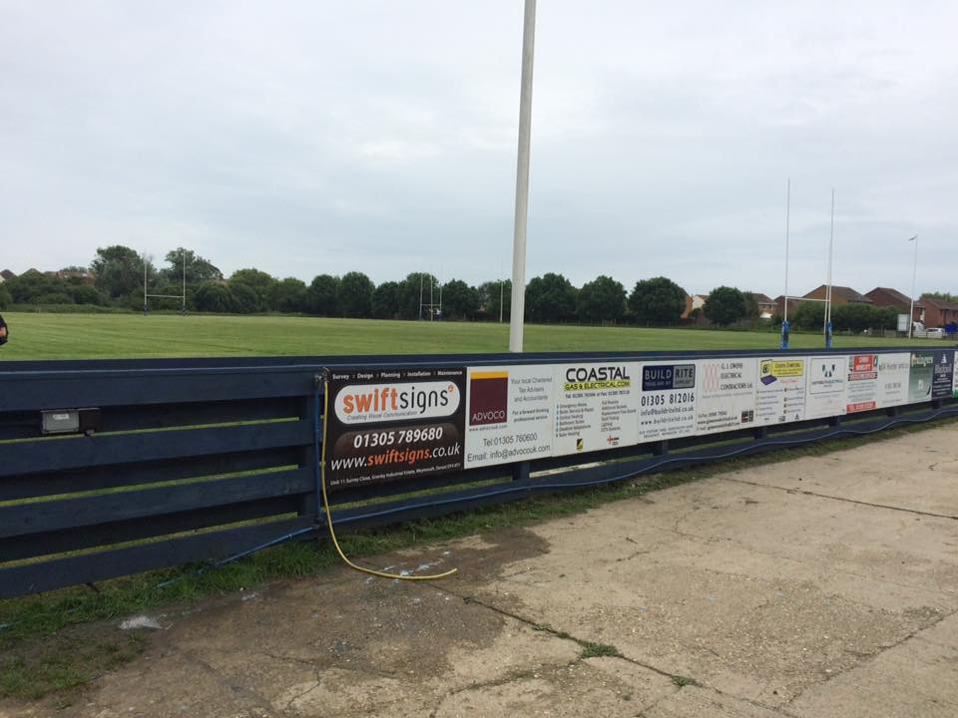
Painting of the fence – inspiring
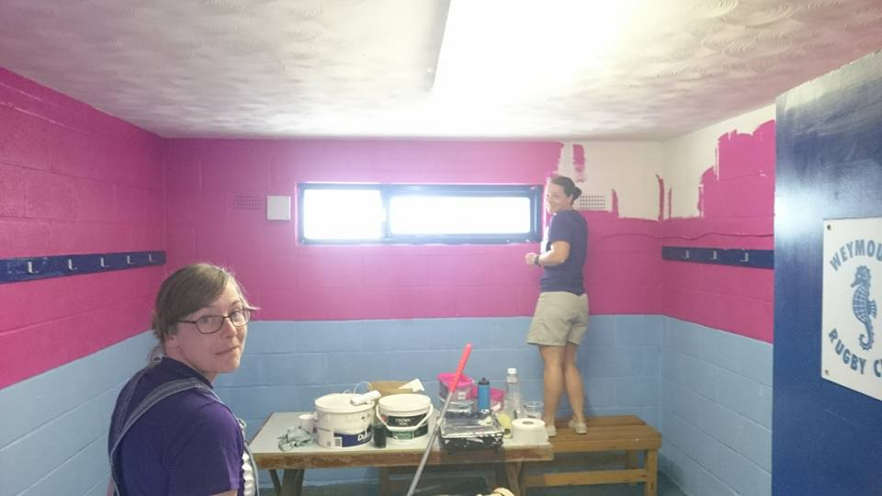
The ladies changing room - speechless

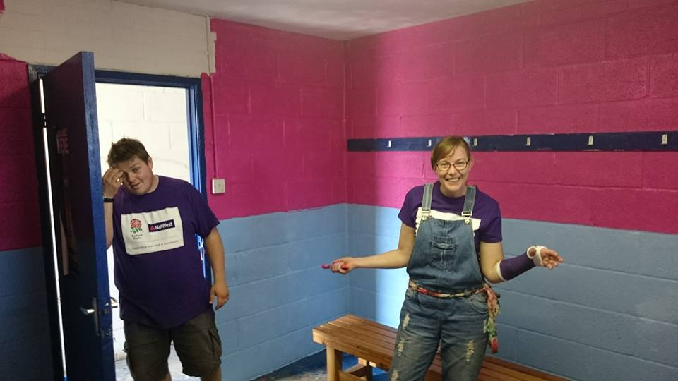
Not so sure about the colour

THE NEW PLAYING SEASON
1ST xv
We started with a good convincing win at home to Oakmeadians in Division 1 (S) but the result was reversed when we travelled to Yeovil who beat us twice last season as well. However Ryan is confident that things are looking good for the season with numbers at training on the increase. We were conceded our cup match as Melksham could not raise a side.
2nd XV
The 2nds have also had a mixed start losing the opening match at Salisbury 4ths who we were beating at half time but in the second half they made a lot of substitutions and ran out easy winners. Against a rather depleted Swanage & Wareham 3rd XV we ran in 9 unanswered tries. Like the 1st XV our cup match was also cancelled as Swindon COB 2nds couldn’t raise a side either.
Colts
The Colts first match of the season was at home to a strong side from Sherborne who scored 50 unanswered points. Despite the loss coach Dave Stone was pleased by the performance of the whole team who never gave up and it was pleasing to be able to field a full side.

Under 16’s
The Under 16’s first match was also against Sherborne who again proved to be the stronger side winning by 44points to 14. However the tables were reversed when Weymouth entertained Bridport and ran out clear winners by 53 points to to 12.
Under 15’s
Playing under floodlights at Dorchester was a new experience for the team who never gave up against a very strong Dorchester side.
Under 14’s
In a very evenly matched game where the lead constantly changed Weymouth were beaten by Bournemouth by just 2 points, 29-31 being the final score.

SUNDAY MORNING HELPERS
Alison Hunter needs helpers on Sunday mornings and has drawn up the list below nominating which age group is to help her in the kitchen. Without your help there will be NO bacon rolls or coffee for anyone, you have been warned. The list is also displayed on the notice board. Alison has no problem with age groups changing dates so long as somebody is there to help each and every weekend.
2nd October | Under 10’s
9th October | Under 16’s
16th October | Under 14’s
23rd October | Under 11’s
30th October | Under 13’s
6th November | Under 15’s
13th November | Under 9’s
20th November | Under 14’s
27th November | Under 12’s
4th December | Under 8’s
11th December | Under 16’s
18th December | Under 15’s

O2 Touch Rugby
Ruth Hicks and Khylo Farley are the two points of contact for any information about O2 Touch Rugby which takes place on Monday evenings at 1830. O2 Touch is open to everybody, young or old, male or female, and is a light hearted, fun form of rugby.

Our New Website
We are currently introducing a new club website which is run by the RFU’s Game Management System (GMS) and will eventually replace the Pitchero website. It will have the same details as Pitchero and the structure is very similar. At the moment it only has our fixtures, results and league tables to date and this new edition of the Club’s monthly newsletter but once it is up and running it is hoped to include match reports, contact details and any news items.
To access the website simply Google “weymouthandportlandrfc.rfu.club”.

October Fixtures
1st October | 1st XV | Bournemouth 3rd XV | H | 1500
1st October | 2nd XV | Ellingham & Ringwood 3rd XV | A | 1500
2nd October | Ladies | Seaford | A | 1400
8th October | 1st XV | Wimborne 2nd XV | A | 1500
8th October | 2nd XV | Oakmeadians 3rd XV | H | 1500
9th October | Under 15’s | Sherborne | H | 1100
15th October | 1st XV | Supermarine (Cup) | A | 1500
16th October | Ladies | Jersey | H | 1400
16th October | Colts | Bournemouth B Colts | H | 1400
21st October | 3rd XV | Dorchester 3rd XV | H | 1900
22nd October | 1st XV | Salisbury 2nd XV | H | 1500
22nd October | 2nd XV | Bournemouth 5th XV | A | 1500
29th October | 1st XV | Sherborne 2nd XV | A | 1500
29th October | 2nd XV | Dinton 1st XV | H | 1500
30th October | Ladies XV | Ellingham & Ringwood & Totton | A | 1400
30th October | Under 14’s | Bournemouth | H | 1100

